**MDF Rose Engine Lathe 2.0**

**with Stepper Motor Drive**



**Instructions for Building**

**Control System for**

**Multiple Stepper Motors**

**Part 2 – MDF Case**

**Version 3.0**

**19 August 2021**

Permission is not granted to manufacture these for sale.

Table of Contents

Bill of Materials 5

Section 1 – Controls Box Enclosure 7

Before Assembly 8

Assembly 12

Electrical Plates for Connectors 13

Section 2 – Assembly of the Control Box Electronics 16

Mounting the Covers 16

Mounting Electronics to the MDF Base 17

Document Version History 18

Some have chosen to put the stepper motor controls in the lathe’s carcass, under the bed of the lathe. However, placing all the pieces together in a separate box gives these benefits:



**MDF Rose Engine Lathe 2.0**

**(B1 and B1A removed)**

1. This controls box is designed be placed under the bed in the MDF Rose Engine Lathe 2.0 (as shown in the picture to the right {the bed cover is removed}).
2. This approach also allows for the controls box to be used with the original MDF Rose Engine Lathe, just placing the box somewhere near the lathe.
3. This also frees up space under the bed for:
   1. Storage of parts or tools, or
   2. Making a gap-bed lathe.
4. The many connections between the various pieces inside the box are already in place and the user does not have to figure out the correct alignment of connectors when building the MDF Rose Engine Lathe.

The details for how we are building the one you can buy are below. These are documented for our use to ensure consistency, and we are publishing them for anyone who wishes to build their own.

The sequence of activities follows the layout of this document. That was done consciously. Changes to the sequence should be considered strongly before making changes.

|  |
| --- |
| Section 1 – Controls Box Enclosure |

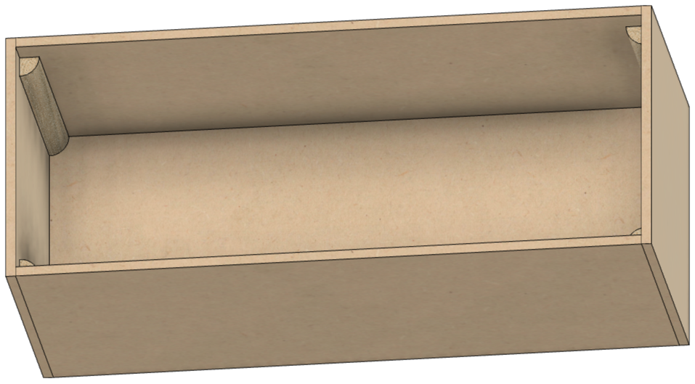

**Bottom**

**Side**

**Side**

**Side**

**Side**

The assembled box has

1. A top and bottom made from ¾” MDF,
2. Four sides made from ¼” MDF, and
3. 4 corner posts made from quarter-round trim (these are recommended but not required. The box can be assembled without them).

Removing the top reveals the interior of the box as shown to the right.

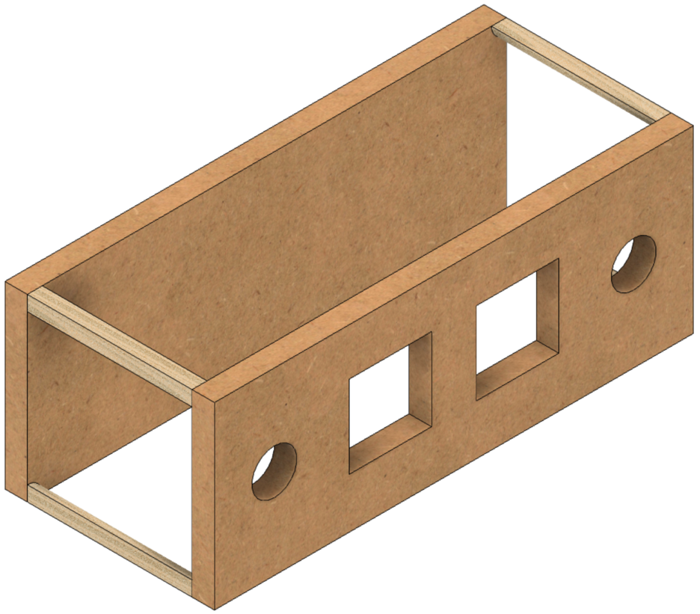

**Top**

**Bottom**

The quarter-rounds are used to give the top and bottom something to set the spacing correctly.

The four ¼” thick sides are screwed to the ¾” MDF used for the top and bottom.

Replacing the top, and removing the sides reveals the view to the left.

## Before Assembly

The following instructions should be followed before assembling the controls box

### Bottom

This is made from ¾” MDF.

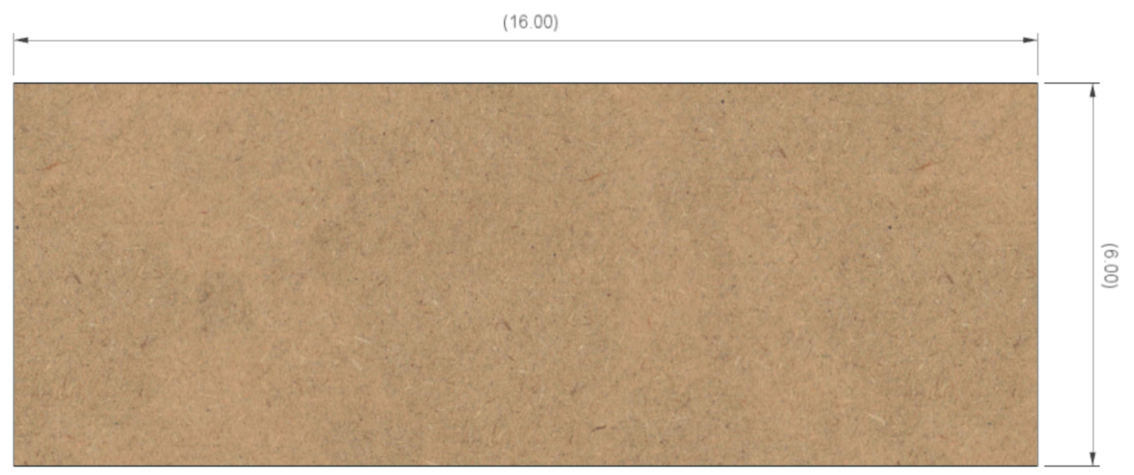

**6”**

**16”**

### Top

1 ½” dia (typ)

This is made from ¾” MDF.

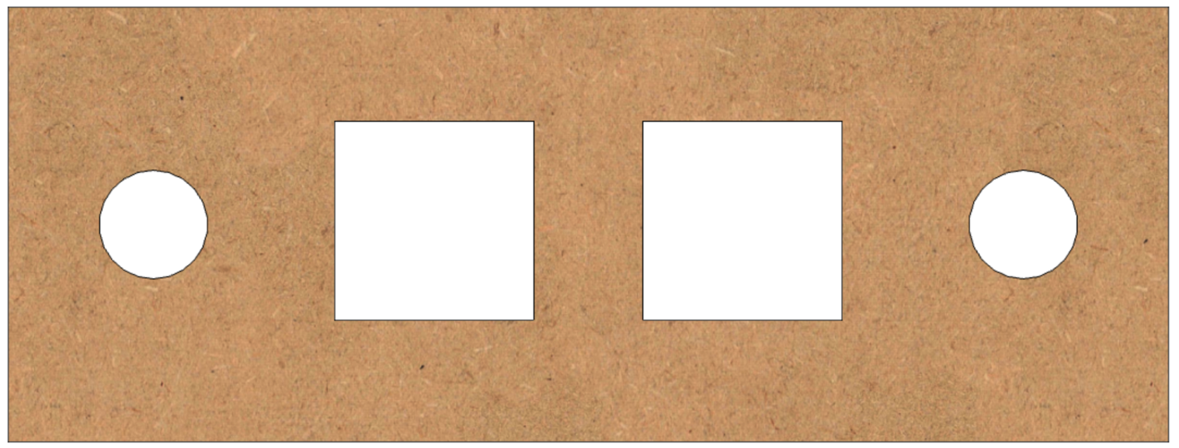

3”

2 ¾”

2 ¾”

6”

2”

2”

2 ¾”

4 ½”

2 ¾”

4 ½”

16”

### Long Sides (2)

There are two of these, and they are made from ¼” MDF.

**16”**

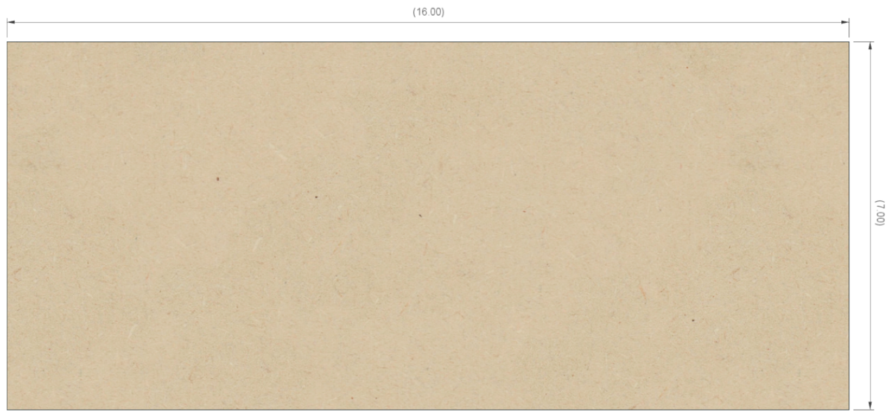

**6 ½”**

### Short Sides (2)

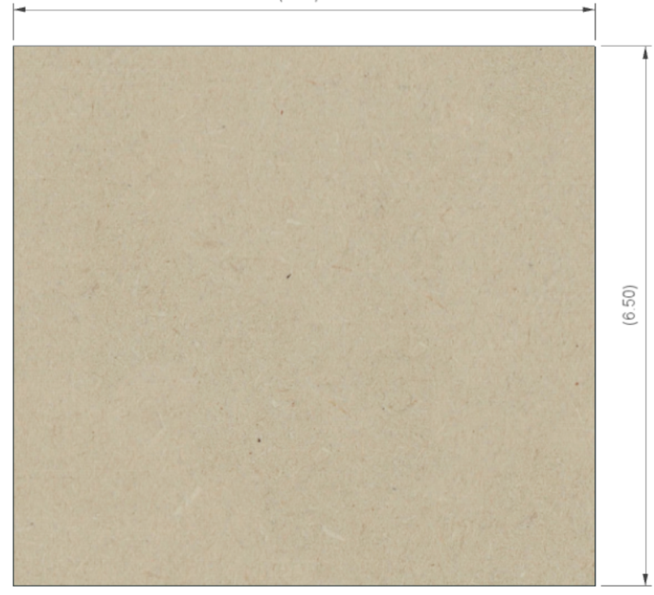

**6 ½”**

**6 ½”**

There are two of these, and they are made from ¼” MDF.

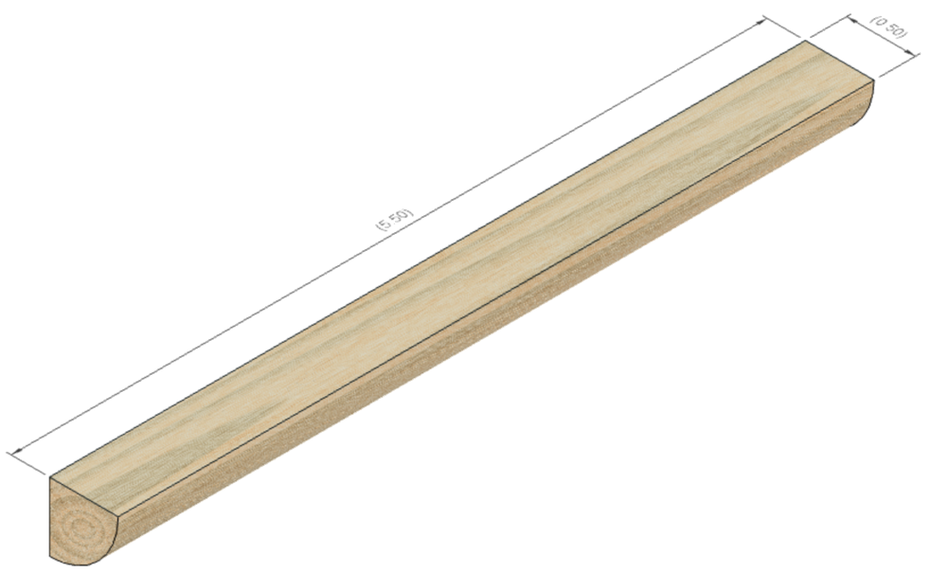

**5”**

**½”**

### Quarter Rounds (4)

There are four of these, and they are made from any good trim material. These are ½” radius, but that is not terribly critical.

## Assembly

Glue the four quarter rounds to the ends of the two long sides. Be certain to:

1. center the quarter round so there is ¾” on each end, and
2. ensure the edges are flush to each other.

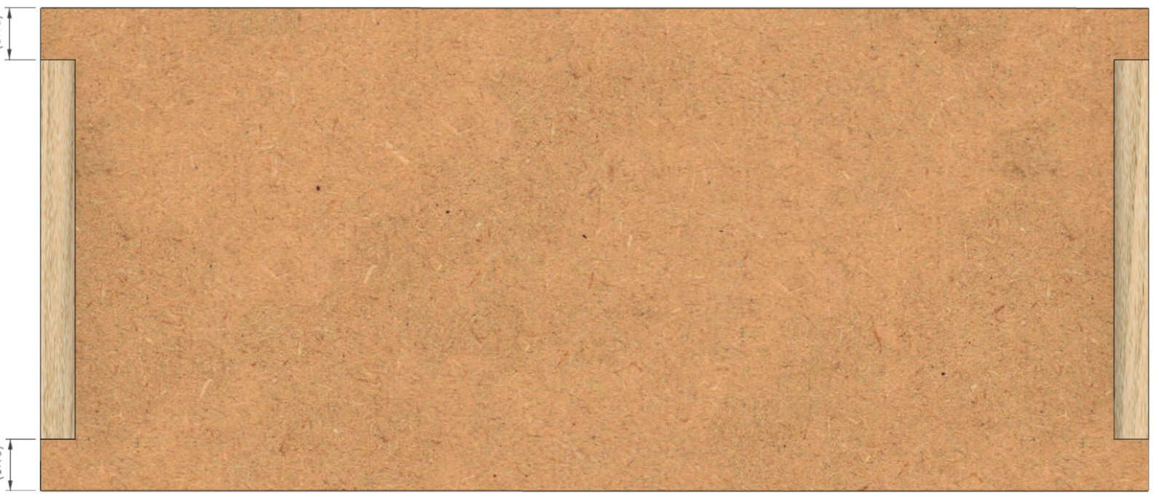

**¾”**

**¾”**

## Electrical Plates for Connectors

### A close up of a speaker Description automatically generatedPower Infeed

Use a 1-gang plate with the hole punched out for the cable strain relief. Secure the power cable in place using the 3/8 in. Twin-Screw Cable Clamp Connector. Wait until later to tighten the screws holding the power cable into place.

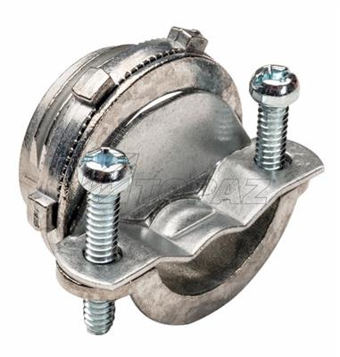

### A computer generated image of a speaker Description automatically generatedPower Switch

****Use a 1-gang plate which is blank. Drill a ½” hole in the center and secure the power switch to it.

### Stepper Motor Plugs



1 ¾”

1 ¾”

**Spindle**

**X Axis**

**Z Axis**

**B Axis**

Use a 2-gang plate which is blank. Drill 4 holes which are each 5/8” diameter.

Label these as:

* Z Axis
* B Axis
* X Axis
* Spindle

### A picture containing sitting, indoor, old, photo Description automatically generatedOther Plugs

1”

1”

1”

1”

¾”

Use a 2-gang plate which is blank.

Drill 6 holes which are each 6mm or 15/64” diameter. Label these as:

**Limit Switches**

|  |
| --- |
| **Limit Switches** |
| **25 26 27** |
| **28 38 39** |

**27**

**25**

**26**

Those numbers represent the pins on the Teensy and should match the ones selected on pg. **Error! Bookmark not defined.** for the Error! Reference source not found..

**39**

**28**

**38**

For the touch screen (the Nextion touch screen), the recommended approach is to use a connector like a GX-12/4 (#215) to connect the wires. For that connector, drill the hole using a 12mm bit. Center it left to right and 1” from the outer edge. Label this as:

**Touch Screen**

**Touch Screen**

|  |
| --- |
| Section 2 – Assembly of the Control Box Electronics |

## Mounting the Covers

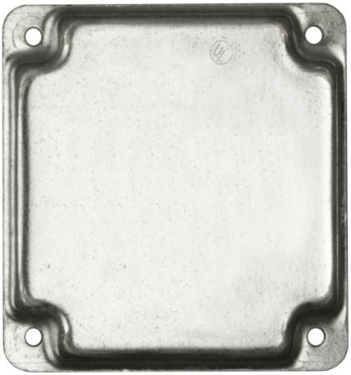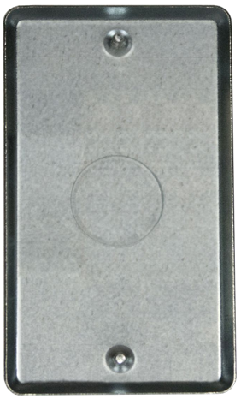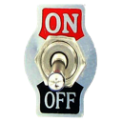The layout below is recommended. This minimizes cable management issues when used.

**Touch Screen**

**Limit & Home Switches**

**#**

**#**

**#**

**#**

**#**

**#**

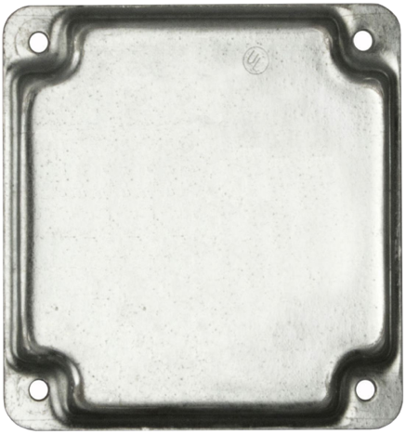

**Spindle**

**X Axis**

**Z Axis**

**B Axis**

**NOTE:** Screw these plates into place using 5/8” #6, flat head, particle board screws (item #408 in the bill of materials).

## Mounting Electronics to the MDF Base

Mount the electronics to the base piece of the MDF. The PCB is secured to the MDF with the ¼” spacers under the 4 corners to place the board so that there is a ¼” gap below.

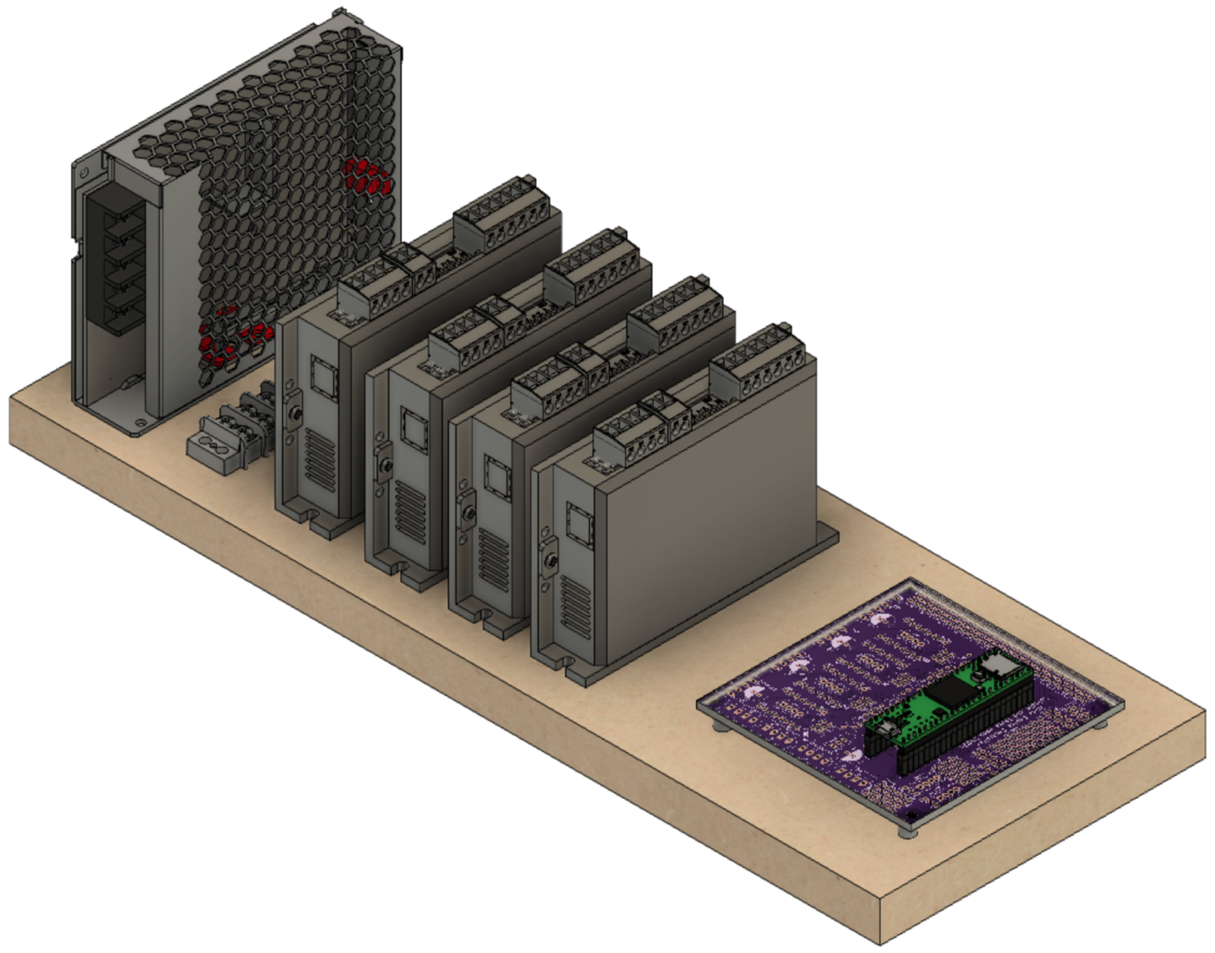

**DM542T – B Axis**

**LRS-100-24**

Spacing between DM542Ts is 1” or so.

**PCB**

(sitting atop spacers)

**DM542T – Spindle**

**DM542T – X Axis**

**DM542T – Z Axis**

**Terminal Block**

# Document Version History

|  |  |  |
| --- | --- | --- |
| Ver | Date | Comment |
| 3.0 | 19 Aug 21 | * Original document split into 3 parts to allow for different case configurations to be handled easily. |
| 2.1 | 14 Aug 21 | * Changed pins used for limit switches * Added information regarding different Teensy and Nextion displays. |
| 2.0 | 13 Jun 21 | * This document incorporates changes to the way cables are attached to the PCB. It now shows how to use connectors in lieu of soldering the wires directly to the board. |
| 1.4 | 10 Mar 21 | * Reorganized a few steps to follow better flow of work. * Added notes on using GX-12/4 connector for Nextion display. * Updated instructions for loading software to reference web site. * Also added a few minor other tweaks. |
| 1.3 | 01 Jan 21 | * Added item numbers for optional build using a Pololu Tic (this is a separate document). * Renamed Document |
| 1.2 | 15 Dec 20 | * Added parts to the bill of materials * Added details on the installation of the 3.5mm phono jacks. |
| 1.1 | 10 Dec 20 | * Added details for optional configurations. * Added information for attaching the stepper motor to the headstock |
| 1.0.2 | 07 Dec 20 | * Updated p/n for item #204; also updated p/n & qty for item #102. * Added note on soldering on 3.5mm jacks first. |
| 1.0.1 | 05 Dec 20 | * Updated commentary about stepper motor needed. * Added information about stepper motor mount, pulleys, and belt. * Updated drawing dimensions. |
| 1.0 | 01 Dec 20 | Initial document |

To the extent that material may appear to be infringed, we assert that such alleged infringement is permissible under fair use principles in U.S. copyright laws. If you believe material has been used in an unauthorized manner, please contact me at [ColvinTools@Gmail.com](mailto:ColvinTools@Gmail.com).

The layout of the Printed Circuit Board (PCB) is copyright Ed French and is used with his permission.

Permission is not granted to manufacture these for sale.